**TWAHIRAH KIDS JUNIOR SCHOOL-BUSULA**

**P.5 END OF TERM II INTERNAL EXAMINATIONS – 2024**

**INTEGRATED SCIENCE**

**Time allowed: 2 hours 15 minutes**

Name: ____________________________________________________________________

***SECTION A***

1. What is the best soil for growing crops?

_________________________________________________________________________________________________

2. State the best way of improving on local breeds of poultry.

_________________________________________________________________________________________________ _________________________________________________________________________________________________

3. How do mushrooms reproduce?

_________________________________________________________________________________________________

4. Why is mercury mostly used in thermometers?

________________________________________________________________________________________________

________________________________________________________________________________________________

5. Apart from nectar, give any one material collected by worker bees from the field.

_________________________________________________________________________________________________

6. How useful are ventilators on your classroom?

_________________________________________________________________________________________________

7. Which type of energy is possessed by a flying bird?

_________________________________________________________________________________________________

8. Give one way how fertilizers can be applied in the garden.

_________________________________________________________________________________________________

_________________________________________________________________________________________________

9. Why is a housefly called a vector?

_________________________________________________________________________________________________

_________________________________________________________________________________________________

10. State any one example of a solvent.

_________________________________________________________________________________________________

11. Give one way how soil can be kept fertile.

_________________________________________________________________________________________________

12. How is the instrument below important to a bee keeper?

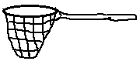 _________________________________________________________________________

_________________________________________________________________________

13. Which non flowering plant reproduces by means of spores?

_________________________________________________________________________________________________

14. Why do medical workers shake clinical thermometer before using them?

_________________________________________________________________________________________________ _________________________________________________________________________________________________

15. What are broilers?

_________________________________________________________________________________________________ _________________________________________________________________________________________________

16. In which way do bacteria reproduce?

_________________________________________________________________________________________________

_________________________________________________________________________________________________

17. Why are worker bees called sterile bee?

_________________________________________________________________________________________________

_________________________________________________________________________________________________

18. Give one reason why a dry wood immersed in water does not sink.

_________________________________________________________________________________________________

_________________________________________________________________________________________________

19. In which way are pests dangerous to crops?

_________________________________________________________________________________________________

20. Why is it bad to drink water prepared through filtration?

_________________________________________________________________________________________________ _________________________________________________________________________________________________

21. Mention one state of matter.

_________________________________________________________________________________________________

22. State any one cause of poultry vices.

_________________________________________________________________________________________________

23. Give one form of energy which is used to iron clothes.

_________________________________________________________________________________________________

24. Which type of teeth is used for tearing food?

_________________________________________________________________________________________________

25. Identify one raw material of photosynthesis.

_________________________________________________________________________________________________

26. Give one danger of wind in the environment.

_________________________________________________________________________________________________

_________________________________________________________________________________________________

27. How do mulches control soil erosion in the garden?

_________________________________________________________________________________________________

_________________________________________________________________________________________________

28. Name the standard unit of measuring weight.

_________________________________________________________________________________________________

29. Calculate the volume of the cuboid below.

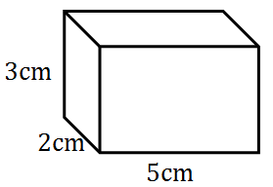

30. Name the insect which pollinates flowers at night.

_________________________________________________________________________________________________

31. In which way can a farmer take care of his garden tools?

_________________________________________________________________________________________________

_________________________________________________________________________________________________

32. John has a swollen neck; which deficiency disease is he suffering from?

_________________________________________________________________________________________________

33. Draw a parallel leaf venation in the space provided below.

34. Which body organ filters blood?

_________________________________________________________________________________________________

35. How is friction important to us?

_________________________________________________________________________________________________

_________________________________________________________________________________________________

36. Write down one advantage of roots to people.

_________________________________________________________________________________________________

_________________________________________________________________________________________________

37. Name the type of teeth shown below.

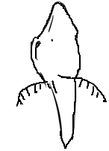

_________________________________________________________________________________

38. Why should a rain gauge be placed in flat open area?

_________________________________________________________________________________________________ _________________________________________________________________________________________________

39. Give one example of annual crop.

_________________________________________________________________________________________________

40. State any one important information found on a child’s health card.

_________________________________________________________________________________________________

_________________________________________________________________________________________________

***SECTION B***

41. (a) What are germs?

_________________________________________________________________________________________________

_________________________________________________________________________________________________

(b) Give any one type of germs you know.

_________________________________________________________________________________________________

(c) How are germs spread to people?

_________________________________________________________________________________________________

_________________________________________________________________________________________________

(d) Write one way through which the spread of germs can be controlled.

_________________________________________________________________________________________________

_________________________________________________________________________________________________

42. ***Use the diagram given below to answer the questions that follow***.

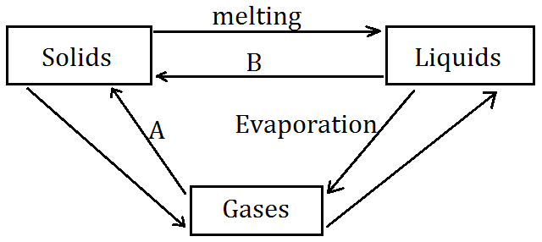

(a) Name the changes marked A and B.

(i) A ___________________________________________________________________________________________

(ii) B __________________________________________________________________________________________

(b) Which substance exists in all the three states of matter?

_________________________________________________________________________________________________

(c) Give one effect of heat on matter.

_________________________________________________________________________________________________

_________________________________________________________________________________________________

43. (a) Identify any one type of germination.

________________________________________________________________________________________________

(b) If all necessary conditions are available for germination, give two reasons why seeds fail to germinate.

(i) _____________________________________________________________________________________________

(ii) ____________________________________________________________________________________________

(c) When should seedlings be transplanted?

__________________________________________________________________________________________________________________________________________________________________________________________________

44. (a) Why is oxygen not used in the preservation of drinks?

_________________________________________________________________________________________________ _________________________________________________________________________________________________

(b) Which property of air enables us to drink soda using a straw?

_________________________________________________________________________________________________

_________________________________________________________________________________________________

(c) Name any two component of air in the environment.

(i) _____________________________________________________________________________________________

(ii) ____________________________________________________________________________________________

45. ***Below is a part of digestive system. Use it to answer the question that follows***.

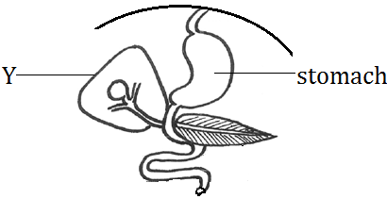

(a) Which digestive juice is produced by part marked Y?

_________________________________________________________________________________________________

(b) Name one enzyme got in the stomach.

_________________________________________________________________________________________________

(c) Where does digestion of food begin?

_________________________________________________________________________________________________

(d) What takes place in the ileum?

_________________________________________________________________________________________________

_________________________________________________________________________________________________

46. (a) Why is free range system practiced in rural areas?

_________________________________________________________________________________________________

_________________________________________________________________________________________________

(b) In which way is record keeping important to poultry farmers?

_________________________________________________________________________________________________

_________________________________________________________________________________________________

(c) What is the incubation period of a hen?

_________________________________________________________________________________________________

(d) Name one type of poultry.

_________________________________________________________________________________________________

47. ***Match the vectors in list A with their diseases in list B.***

**A B**

Ticks Trachoma

Itch mites polio

Cockroaches scabies

Houseflies typhus fever

(i) Ticks ____________________________________________________________________________

(ii) Itch mites ____________________________________________________________________________

(iii) Cockroaches ____________________________________________________________________________

(iv) Houseflies ____________________________________________________________________________

48. (a) Give any one cause of dehydration.

_________________________________________________________________________________________________

(b) Name one important mineral salt which is lost during dehydration.

_________________________________________________________________________________________________

(c) Why should a dehydrated person be given O.R.S?

_________________________________________________________________________________________________ _________________________________________________________________________________________________

(d) Write S.S.S in full.

_________________________________________________________________________________________________

49. (a) In which way is fungi important to people?

_________________________________________________________________________________________________

_________________________________________________________________________________________________

(b) How should we prevent diseases caused by fungi?

_________________________________________________________________________________________________

_________________________________________________________________________________________________

(c) Name two examples of fungi.

(i) _____________________________________________________________________________________________

(ii) ____________________________________________________________________________________________

50. (a) How can we take care of the animals in the environment?

_________________________________________________________________________________________________

(b) Give a reason why dogs are kept at home?

_________________________________________________________________________________________________

(c) In which way are wild animals dangerous to us?

_________________________________________________________________________________________________ _________________________________________________________________________________________________

(d) State one example of wild animal.

_________________________________________________________________________________________________

51. (a) Suggest any two items used for promoting oral health.

(i) _____________________________________________________________________________________________

(ii) ____________________________________________________________________________________________

(b) Write down two ways of keeping our bodies clean.

(i) _____________________________________________________________________________________________

(ii) ____________________________________________________________________________________________

52. (a) In which two ways can food be preserved?

(i) _____________________________________________________________________________________________

(ii) ____________________________________________________________________________________________

(b) Name any one danger of eating food with dirty hands.

_________________________________________________________________________________________________ _________________________________________________________________________________________________

(c) State one disease spread through poor handling of food.

_________________________________________________________________________________________________

53. (a) Why should we give first aid to a casualty?

_________________________________________________________________________________________________

_________________________________________________________________________________________________

(b) Which type of injury is caused by steam?

_________________________________________________________________________________________________

(c) Identify two components of first aid kit.

(i) _____________________________________________________________________________________________

(ii) ____________________________________________________________________________________________

54. (a) What are weeds?

_________________________________________________________________________________________________

_________________________________________________________________________________________________

(b) State any one advantage of weeds.

_________________________________________________________________________________________________

_________________________________________________________________________________________________

(c) Name one common weed in the environment.

_________________________________________________________________________________________________

(d) In which way can weeds be controlled?

_________________________________________________________________________________________________

_________________________________________________________________________________________________

55. Complete the table below correctly.

|  |  |  |
| --- | --- | --- |
| **Disease** | **Vaccine** | **Site** |
|  | Measles vaccine | Left upper arm |
| Tuberculosis |  | Right upper arm |
| Whooping cough | DPT vaccine |  |
|  | Polio vaccine | Mouth |

***\*\*\*\*\*GOD BLESS\*\*\*\*\****